**All About Crunchbase**

Contents:

1. What is Crunchbase?

Wiki: Crunchbase is a platform for finding business information about private and public companies.

**Crunchbase** information includes investments and funding information, founding members and individuals in leadership positions, mergers and acquisitions, news, and industry trends.

**Products:**

* Crunchbase Pro: -
  + offers more advanced search capabilities
  + market trend analytics,
* Crunchbase Marketplace: -
  + search and analyze companies with integrated third-party data sources (for eg. data like web traffic, tech stack, IT budgets)
* Crunchbase Enterprise:- data like web traffic, tech stack, IT budgets such as:
  + setting up and following investment trends
  + identifying and tracking growth industries
  + identifying companies that are close to their own (identifying competitors)
* Crunchbase for application: This tool allows users to integrate Crunchbase data into their product, providing their customers the ability to automatically contextualize prospects to prioritize their sales pipeline and identify key buy signals

1. What we can do with crunchbase?

* Follow companies to check their sales growth and how much money they raised.
  + Entrepreneurs follow potential investors
  + Venture capitalist follow young start ups
* Get to know competitors of a company and compare.
* Make yourself known by joining as a contributor and directly editing your organization or individual profile page.

1. Crunchbase Dataset : <https://data.crunchbase.com/docs/daily-csv-export>

Columns in the dataset: 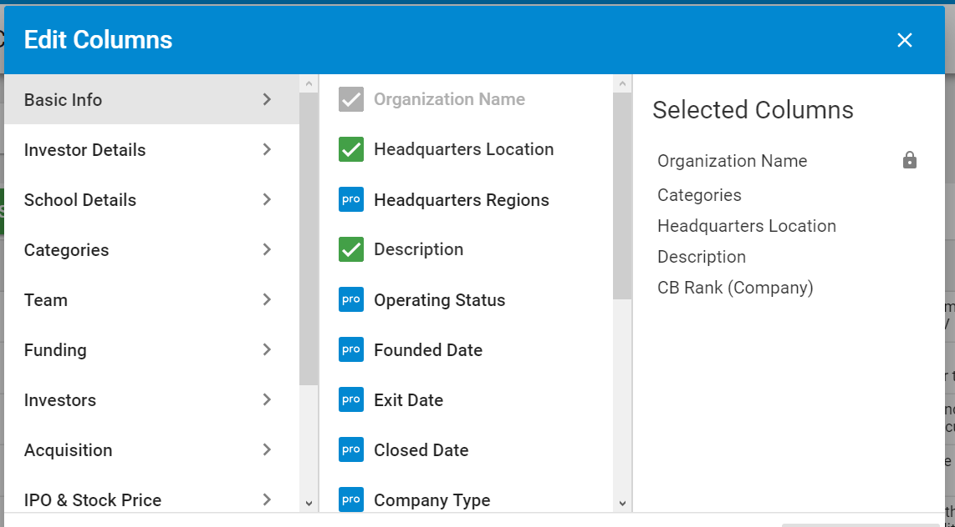

1. Questions to formulate around the dataset: << To be discussed >>

Comments:

For me, there is still an understanding gap of how a business runs so I need to get clear with the basics and then I can think of anything concrete of what question we can formulate (including analysis, prediction and visualization ) over the dataset, extensively. - Subhashree